SKR &SKR GOVT COLLEGE FOR WOMEN (A) KADAPA
DEPT OF ZOOLOGY


COMMUNITY SERVICE PROJECT

Report Presented
by
E. Reddy Manvitha
21440314014

Smt.Dr.P.Subbalakshumma Dr.v.Ravi sekhar

Principal Mentor

DEPT OF ZOOLOGY
SKR & SKR GOVT COLLEGE FOR WOMEN(A)
COMMUNITY SERVICE PROJECT
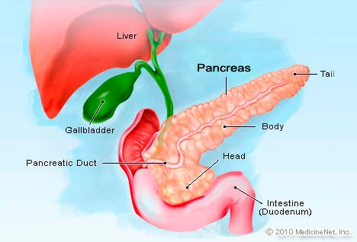
TITLE OF PROJECT
“ Prevalance of diabetes in 23 ward , Nagarajupeta,Kadapa ”
Submitted
by
E.Reddy Manvitha

Supervision
By

Dr.V.Ravisekhar
Lect in zoology
Smt.Dr.P.Subbalakshumma Dr.v.Ravi sekhar Principal Mentor
S.No | Index | Page No | Remark
1  2  3  4 | Mapping of students  Survey related photos  Format Quastionnaire  Report  - Introduction  (b) Project specifications  (©) Methodology  (d) Analyses of the problems  €e) Recommendations and c Conclusions  (f) References | 1  2-7  8-10  11-12  13-14  15-16  16-18  19  20

Mapping of the Students : 1

Program combination : Ist Bt.Z.C
Subject : Zoology
Academic year : 2021-22
Number of students : 20
Place : 23 ward ,Nagarajupet,Kadapa

SNO |  | HALL TICKET |  | NAME OF THE STUDENT |  | PHONE NUMBER
1. |  | 21440314001 |  | AKKEM SANDHYA VANDANA |  | 7780790785
2. |  | 21440314002 |  | ANDE SHANTHI |  | 9704926654
3. |  | 21440314003 |  | AVULA LAVANYA |  | 9381406573
4. |  | 21440314004 |  | BATHALA SIVA KUMARI |  | 7993056374
5. |  | 21440314005 |  | CHARU MUNI POOJITHA |  | 9010307005
6. |  | 21440314006 |  | CHEVULA NANDINI |  | 9963463717
7. |  | 21440314007 |  | CHILAKALA SHABANA |  | 9391212467
8. |  | 21440314008 |  | CHINTAKUNTA SIREESHA |  | 8106854737
9. |  | 21440314009 |  | CHUKKA VYSHNAVI |  | 7330919473
10. |  | 21440314010 |  | DANDU SOWJANYA |  | 7032367302
11. |  | 21440314011 |  | DERANGULA BHUVANESWARI |  | 8106167125
12. |  | 21440314012 |  | DEVA SHIREESHA |  | 9390572320
13. |  | 21440314013 |  | ENUGULA PUJITHA |  | 8106662358
14. |  | 21440314014 |  | ENUKOLU REDDY MANVITHA |  | 9441151966
15. |  | 21440314015 |  | ERAGAM REDDY JAYA SRAVANI |  | 9160912813
16. |  | 21440314016 |  | GANGANA PALLI NIRMALA |  | 7382865891
17. |  | 21440314017 |  | GONDI ANUPAMA |  | 9160153960
18. |  | 21440314018 |  | JANGITI NAGA SWETHA |  | 7095963684
19. |  | 21440314019 |  | KALVA GOWTHAMI |  | 8328315234
20. |  | 21440314020 |  | KASUNURU RESHMA |  | 6305396705

Survey related photos: 2 24/05/2022
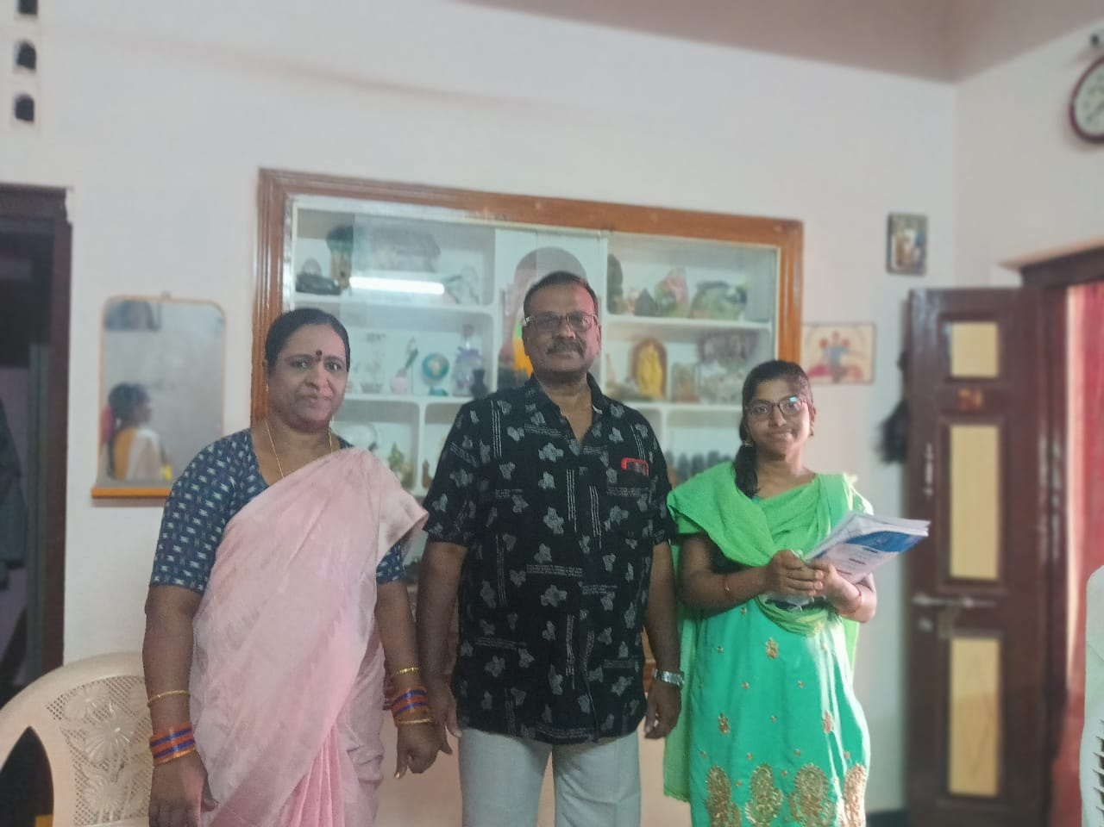 | 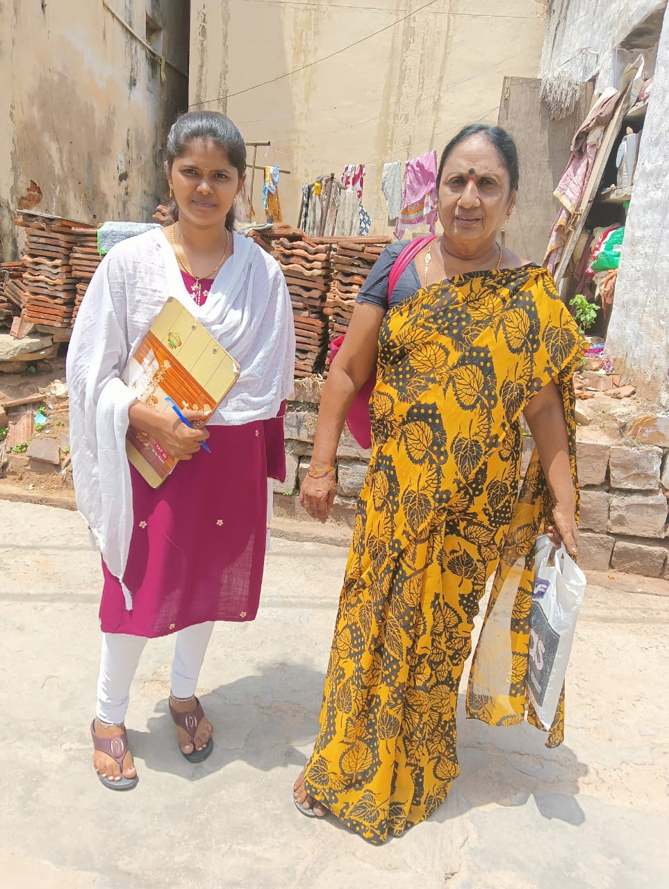
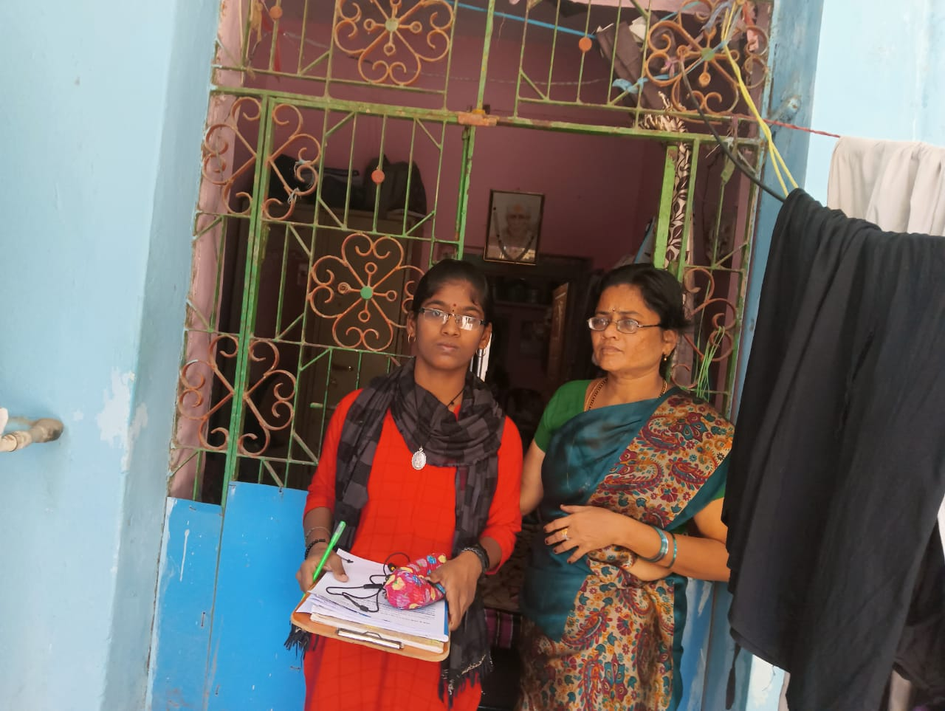 | 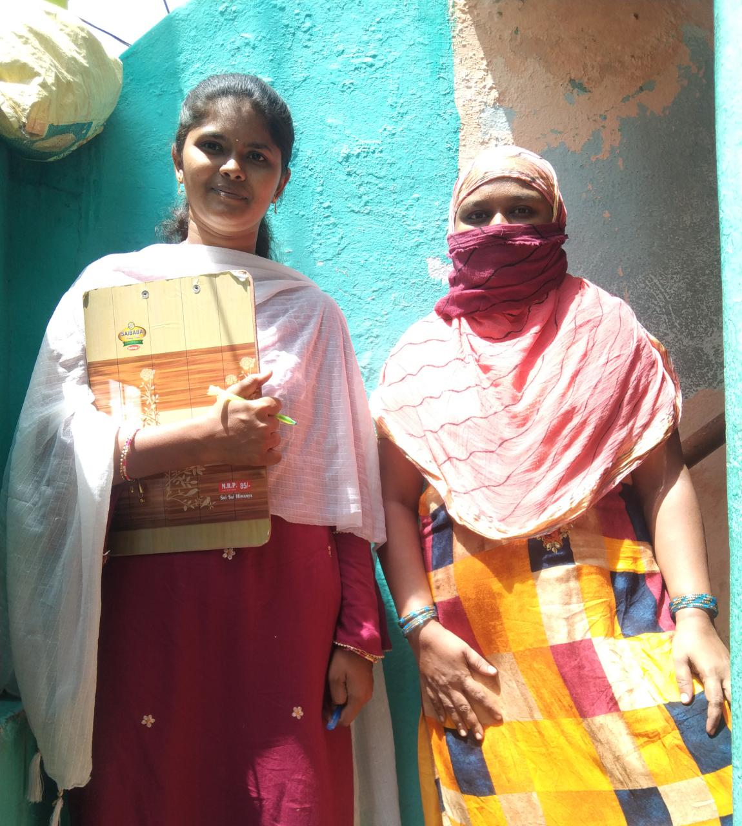

25-05-22 3
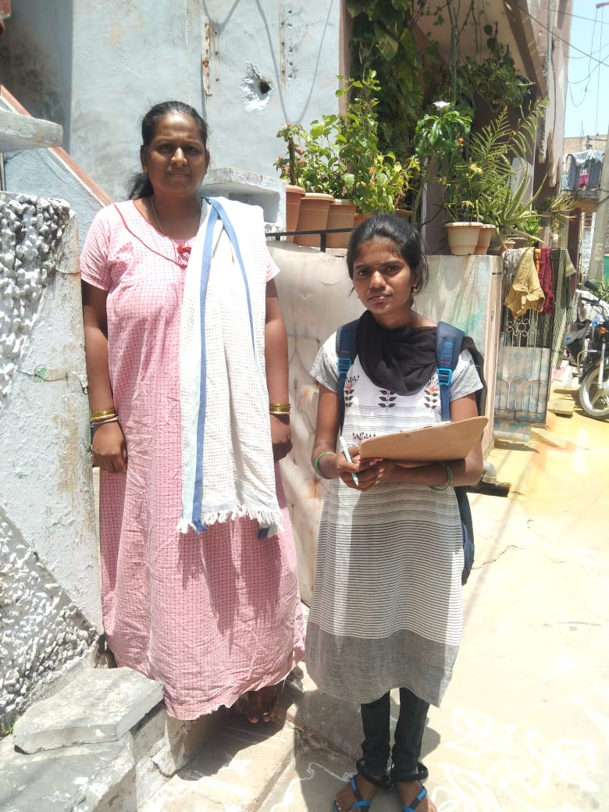 |  | 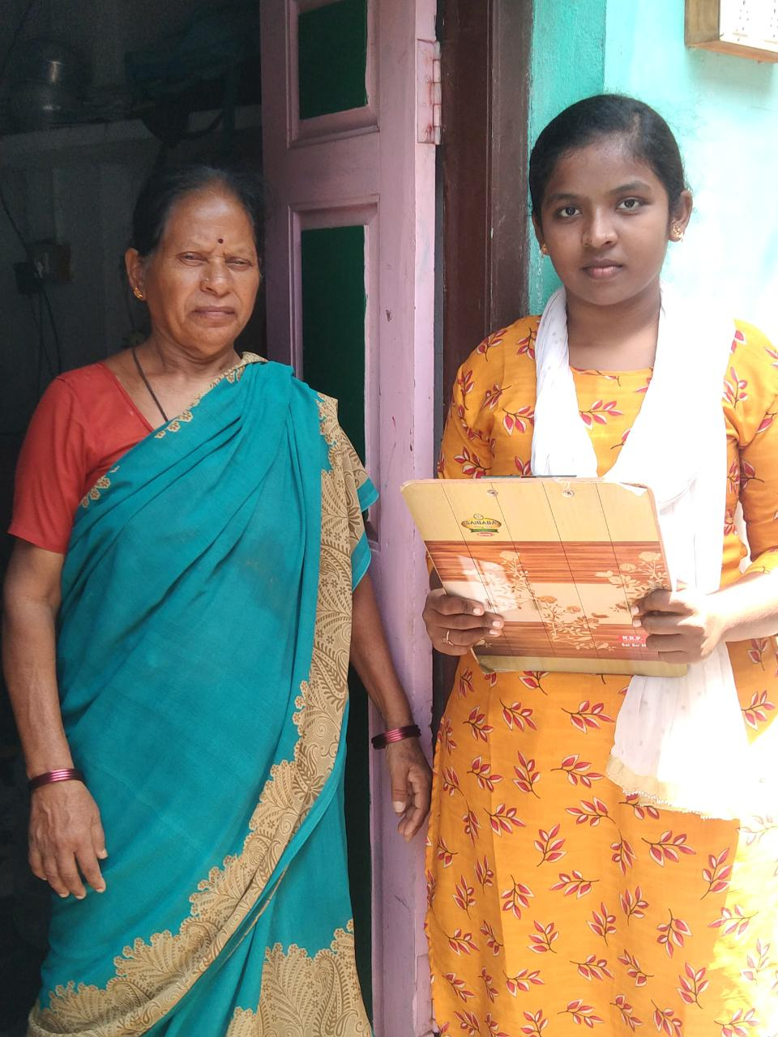
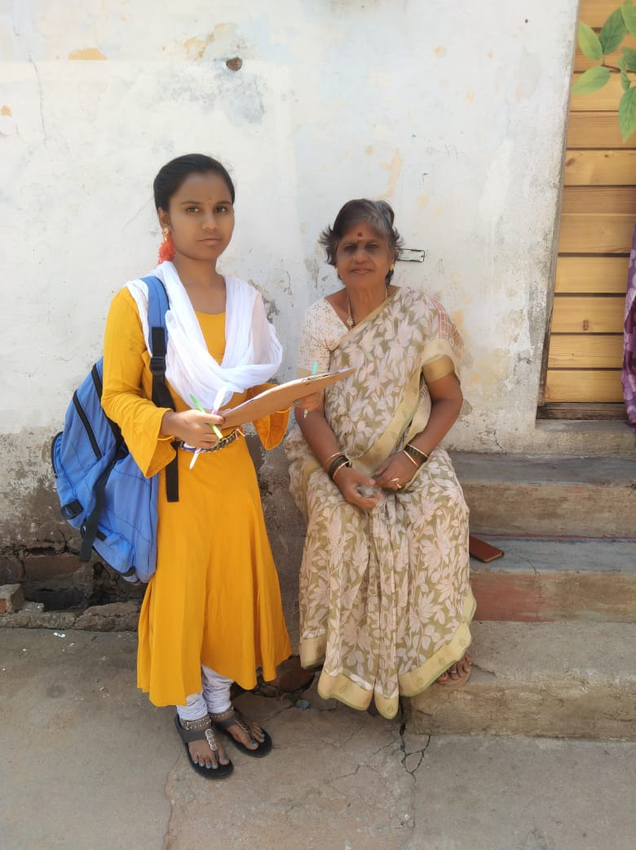 |  | 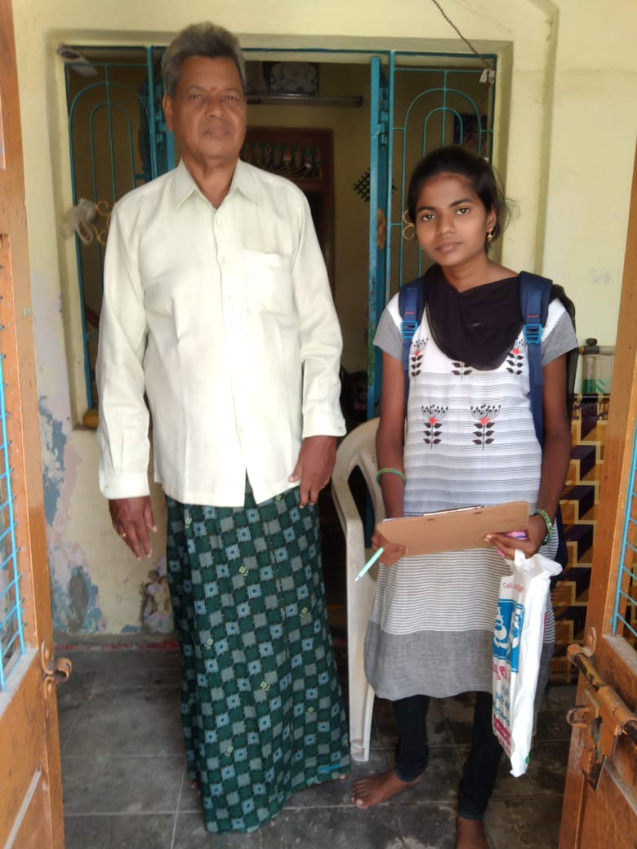
26-05-22
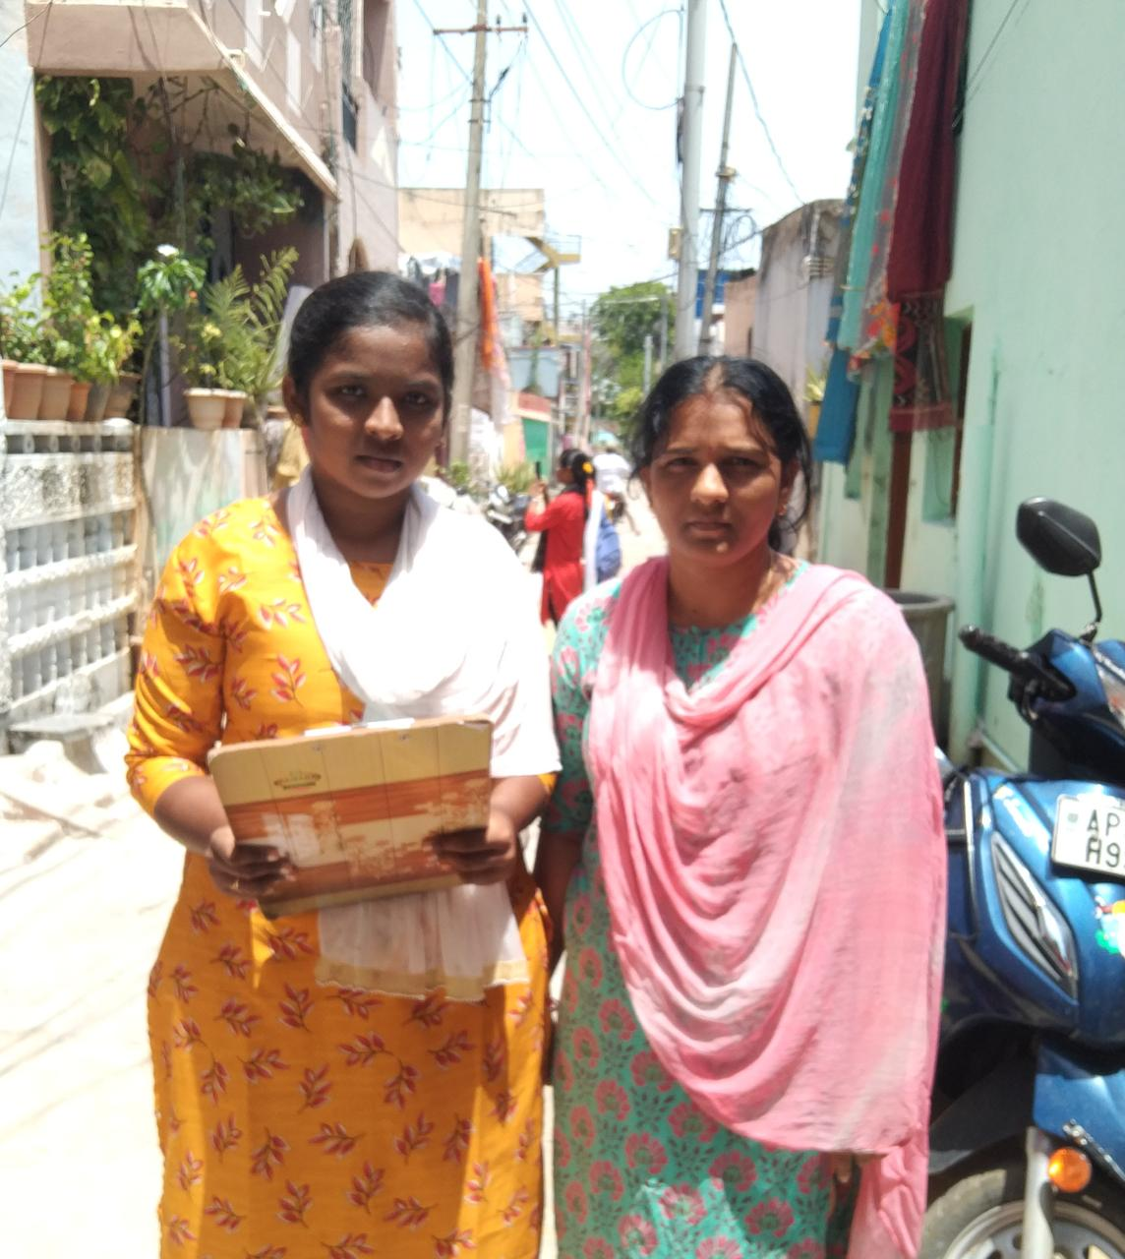 | 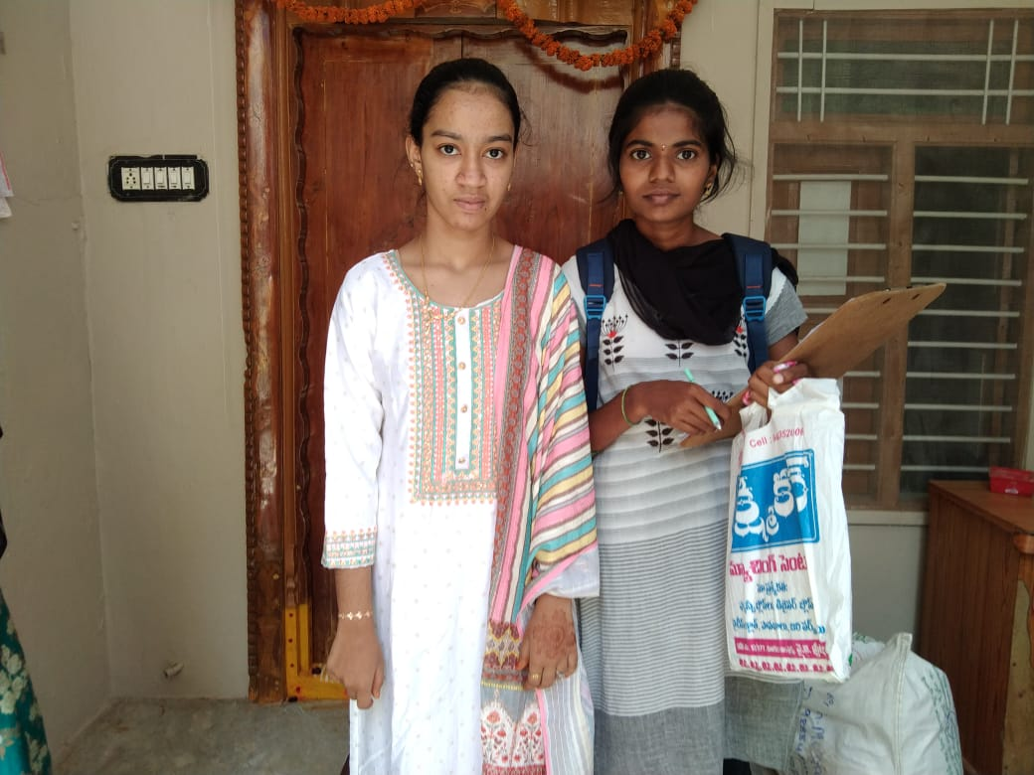
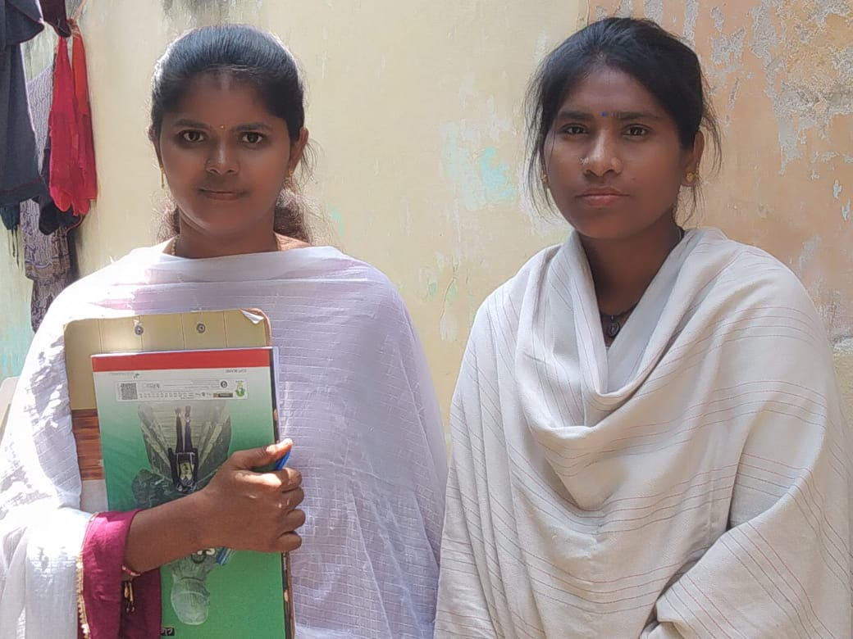 |  | 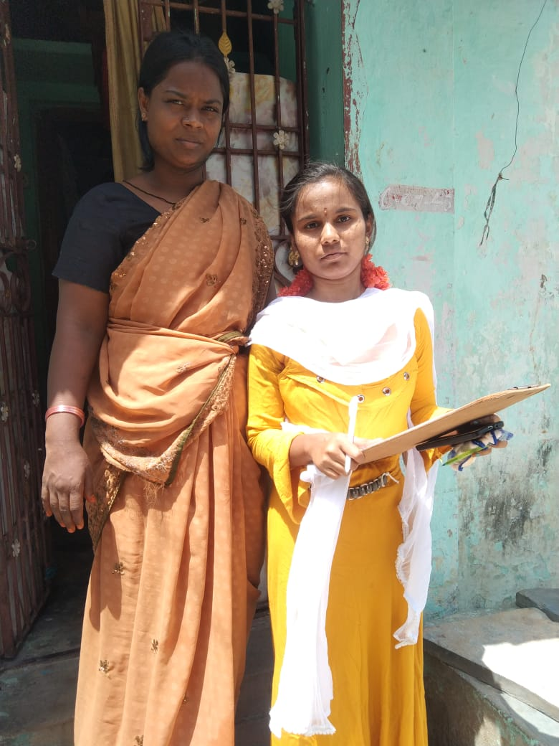
27-5-22 5
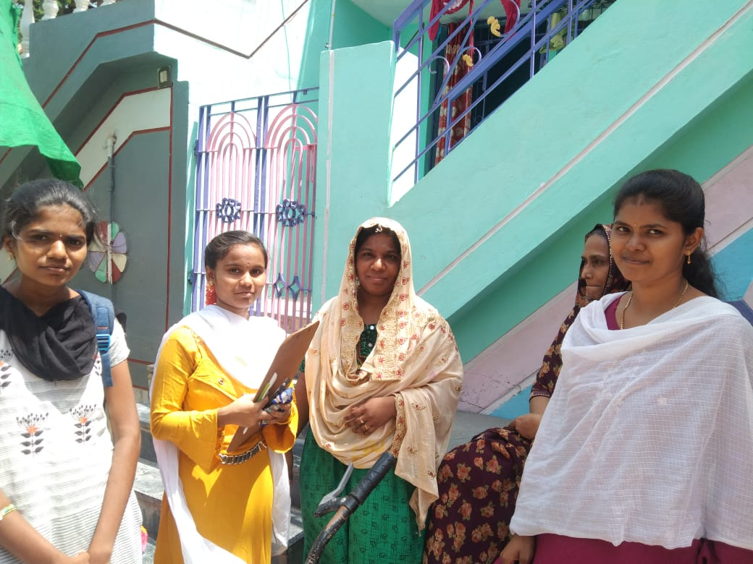 | 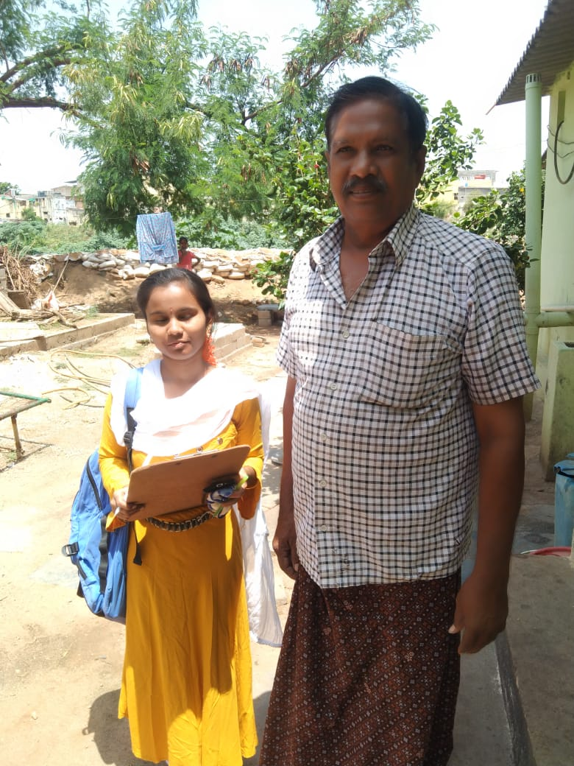
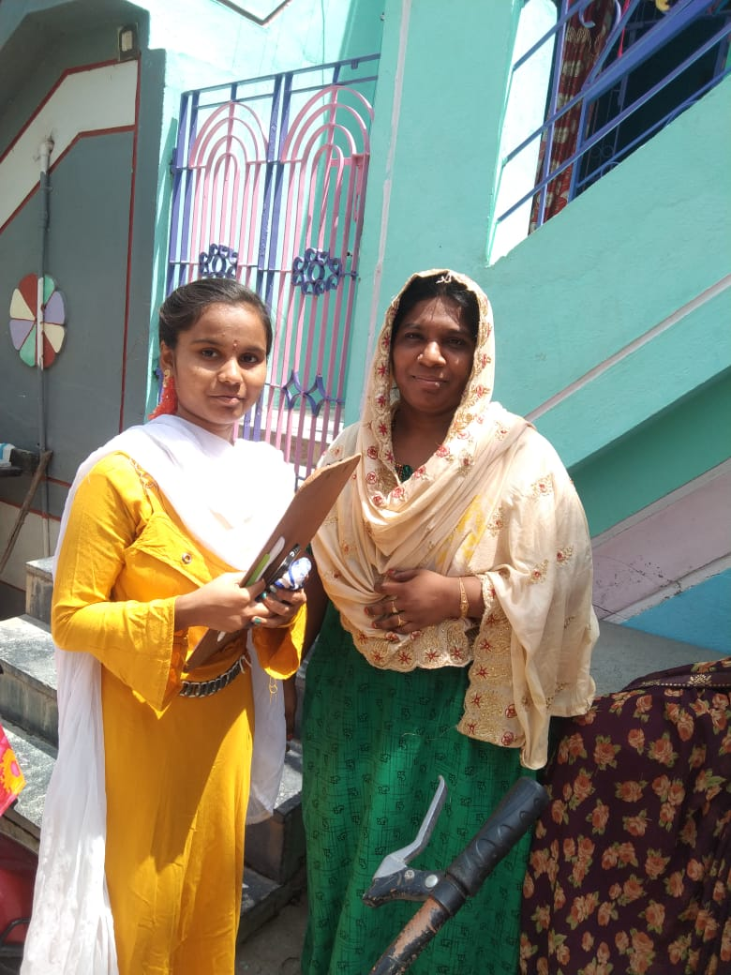 | 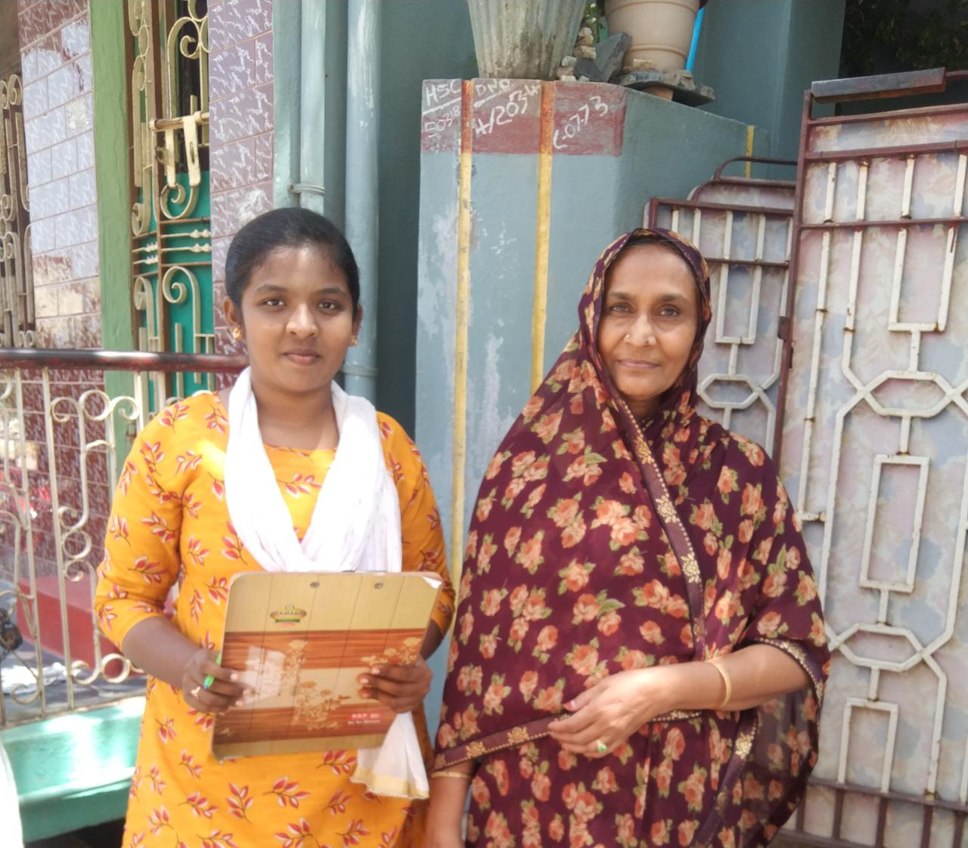

28-5-2022 6
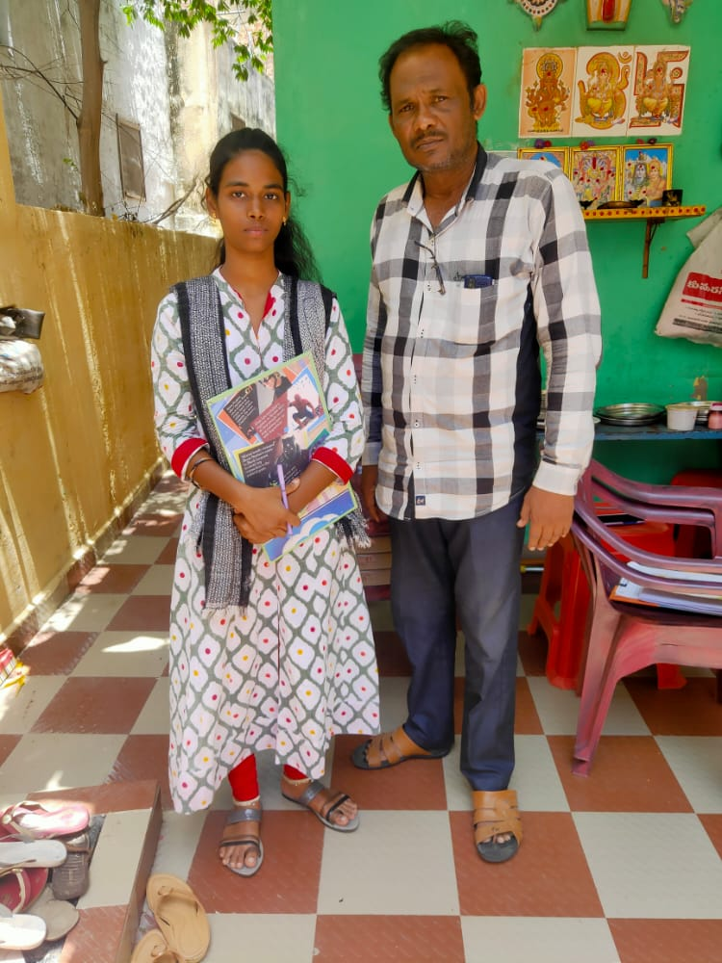 | 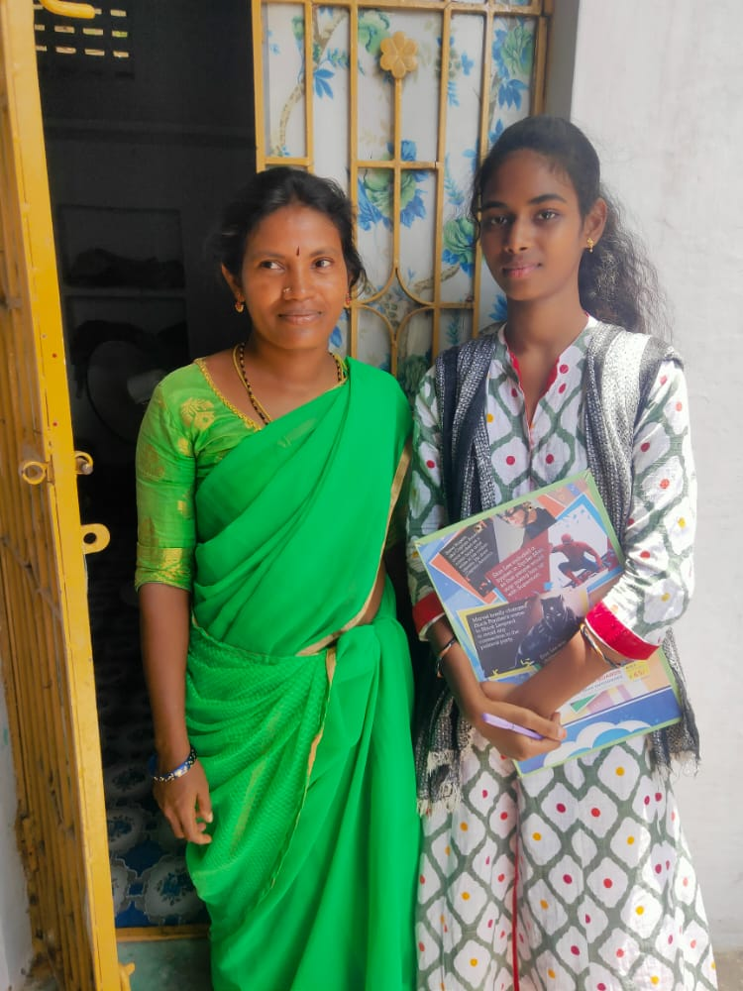
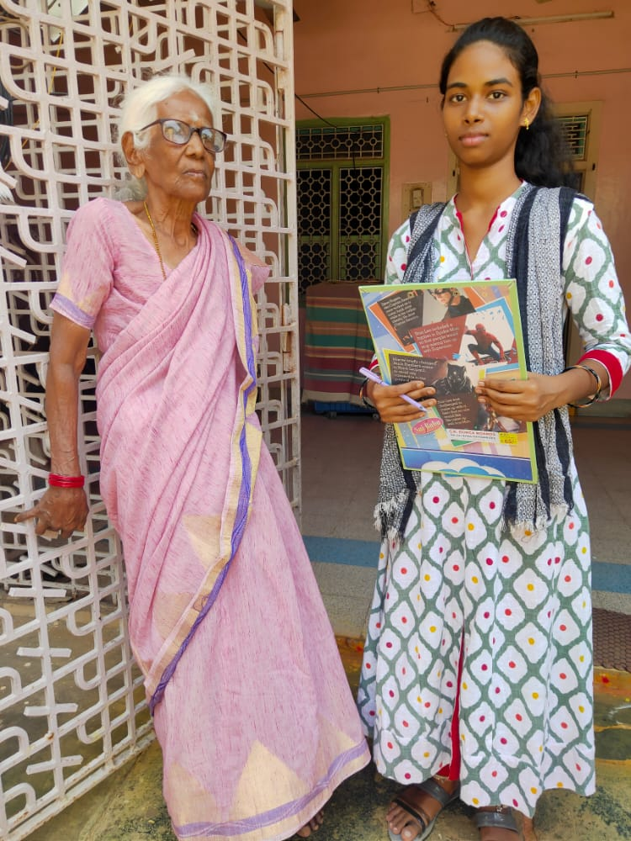 | 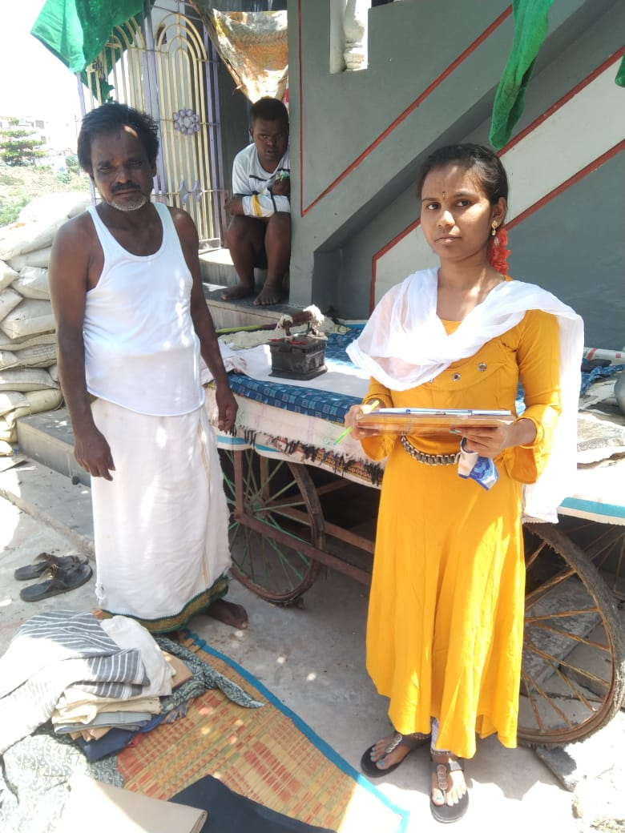

1-6-2022 7
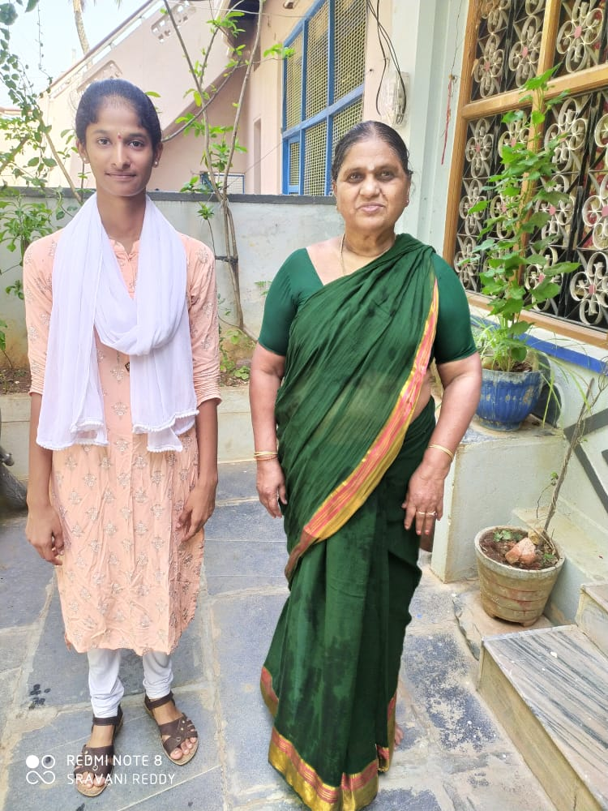 | 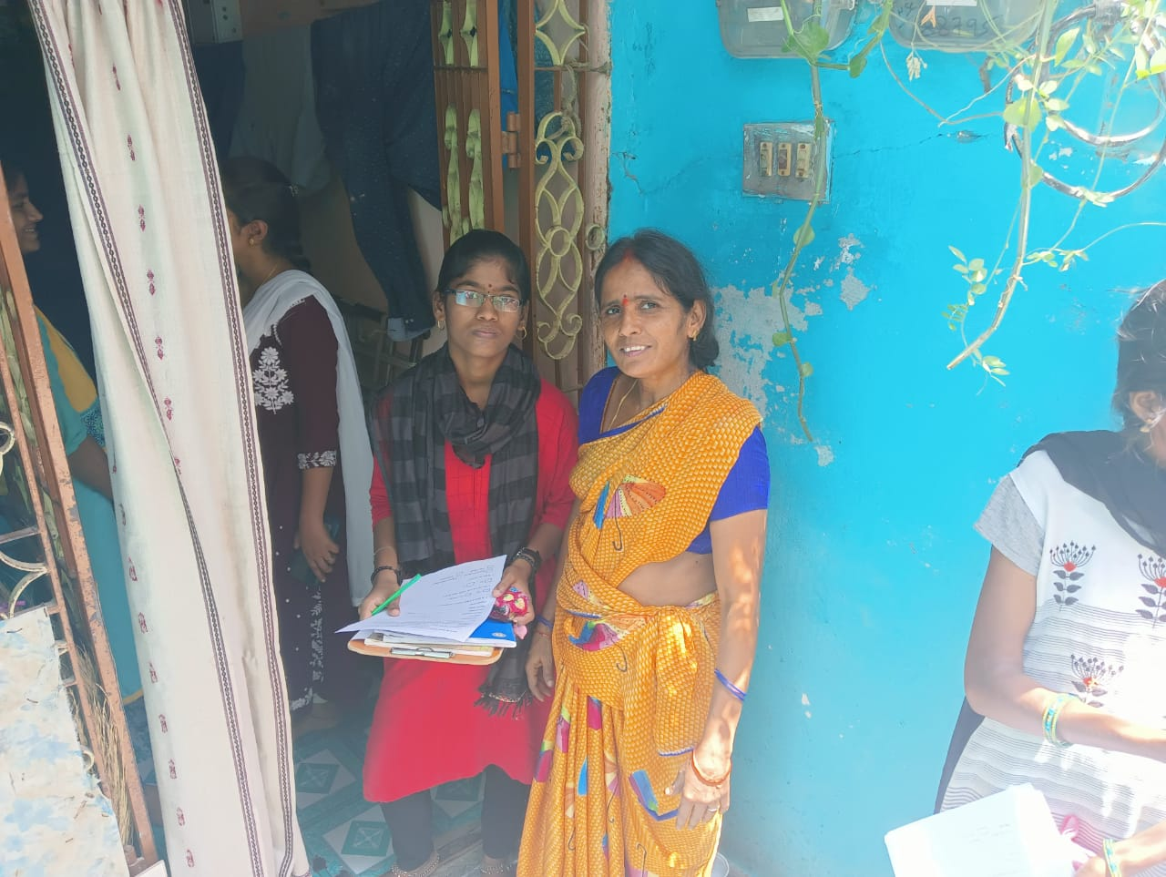
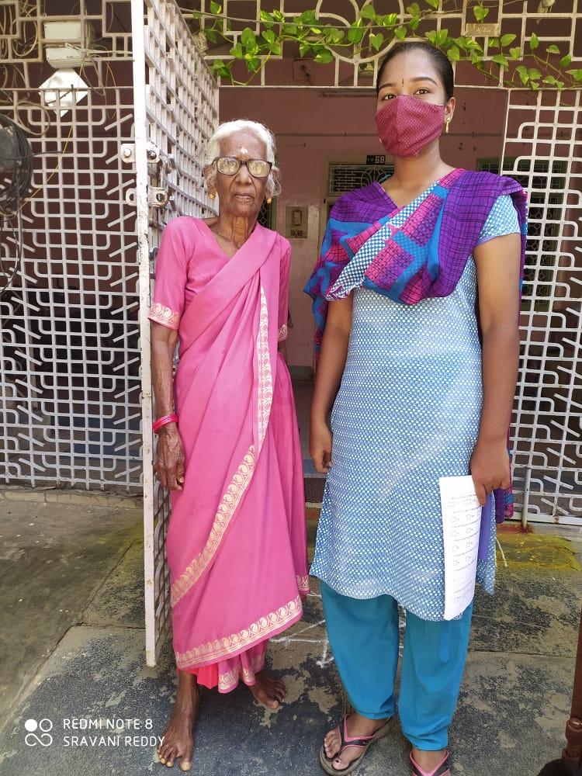 | 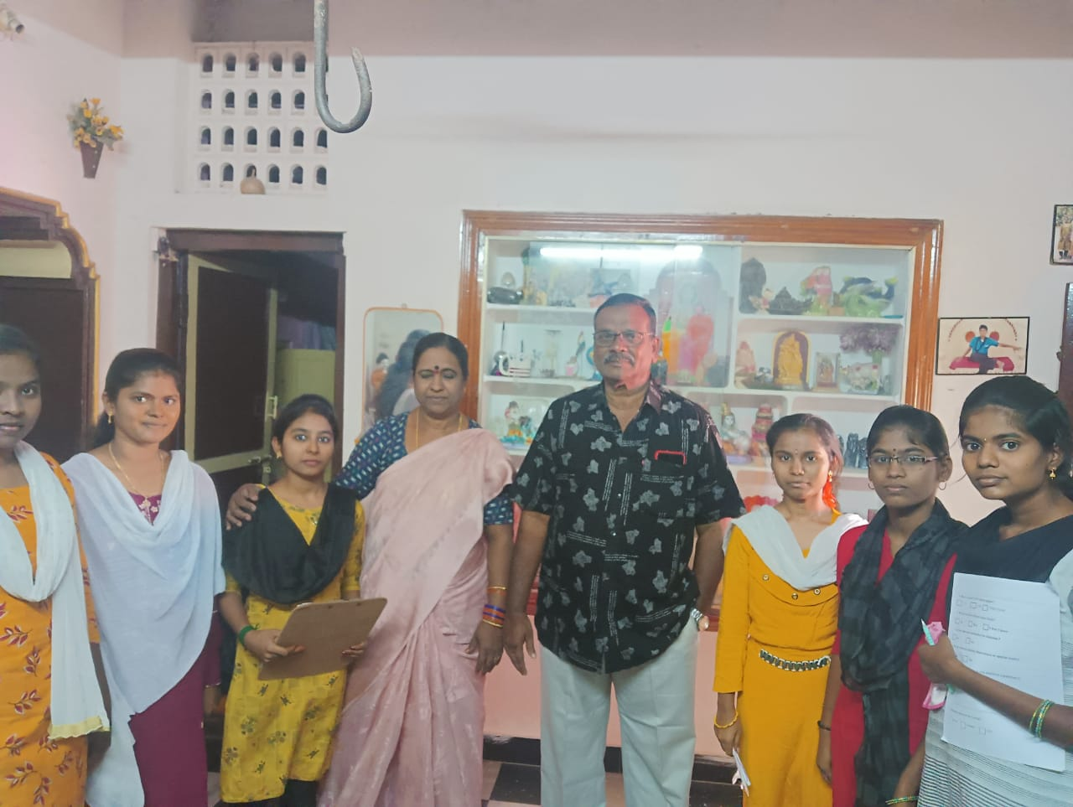

Report
Aim:

we aimed to collect information regarding the prevalence of risk of diabetes in 23rd ward people of Nagarajupeta,Kadapa, Kadapa (dist) , using a validated questionnaire.

Methods adapted:

questionnaire based survey was conducted by the first Bt.Z.C students on all adults in
the 23 rd ward nagarajupeta, Kadapa. The students has collected information from
house hold through the survey form.

Timeline:
First week:
Community survey. This includes the door-to-door survey along with the collection of data in the form of questionnaire. Different age groups ,gender and finance status are selected for the collection of data. A comparative study of prevalence of diabetes in different age groups and gender of people is taken up for this purpose.
Second week:
Community awareness. Under this programme, an attempt to create the awareness regarding the diabetes disease has been made by the team members individually. Different age groups are addressed separately for this purpose.
Third week:
All the data collected has been compiled in the form of project report. This includes the analysis of data. Based on this, definite conclusions are drawn regarding the prevalence of the disease. This includes the graphical representation of the data.
Fourth week:
It includes the presentation of our project work to the internal viva committee at the college level individually.

Tools and techniques used:
Although no specific clinical tools are used in this project, the formats listed below are used for collecting data and drawing conclusions.

SKR & SKR GOVT COLLEGE FOR WOMEN (A),KADAPA.
DEPT OF ZOOLOGY.
COMMUNITY SERVICE PROJECTS QUESTIONNAIRE.
TOPIC : PREVALENCE OF DIABETES IN 23 A W WARD, NAGARAJUPET, KADAPA
Name Of the house holder :
No of family members :
Date :
Occupation :
Address :
Phone number :
Nationality : Caste :
Doctor name :
Patient name : Gender : Age :
- Is there a family history of diabetes?

No yes (whom)
- Do you test your blood sugar level?

No yes

- When do you test?

Before break fast Before lunch/dinn 10
After Meals At bed time

- Have you had LOW blood sugars?
No yes I Don’t know

- Do you ever have high blood sugar levels?

No Yes I Don’t know

- Do you take any medication for diabetes ?

No Yes

- Do you have any Dietary Restrictions or special meals?

No Yes

- Do you take any vitamins or any nutrition supplemets?

No Yes

- Do you have any other health problems?

A :
____________________________________________

- Economy status of the family?

Poor middle rich

Introduction:
Diabetes mellitus is a disorder caused by the deficiency of insulin. Insulin is the hormone secreted by pancreas. Pancreas is a heterocrine gland. It is a mixed gland containing both exocrine and endocrine parts. Endocrine part of Pancreas was identified by Paul Langerhans. Hence the endocrine part of pancreas is named after its discoverer as Islets of Langerhans. This endocrine part contains α and β cells. Α cells secrete glucagon and β cells secrete insulin. Insulin and glucagon are the antagonistic hormones, and they play a crucial role in the maintenance of glucose levels within the body.
Glucose is the secret of our energy, and it is the only molecule that can cross the blood- brain barrier. Brain can utilize only glucose as the source of energy. If glucose is not available to the brain, the person enters into coma. Hence It is mandatory for the human body to maintain the prescribed level of glucose in the blood during fasting and also after a feast. Prescribed level of glucose in the blood during fasting is 90-120 mg/Dl. Postprandial glucose level should not exceed 160 mg/Dl. Excess accumulation of glucose in the blood results in a condition called diabetes mellitus and this is commonly called sugar disease.
In India, day by day cases of diabetes are rising. Identified reasons for the occurrence of diabetes are listed below.
- Damage to pancreas
- Malfunctioning of pancreas
- Aging
- Hereditary factors.
- Irregular diet
- Stress
- Irregular sleeping habits
- Unhealthy lifestyle

12

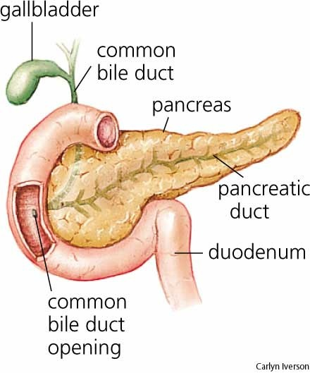

Insulin: Insulin is secreted by the β cells of pancreas. It facilitates the conversion of excess glucose into glycogen. Conversion of glucose into glycogen is called glycogenesis. As glucose is highly soluble in water, it cannot be stored in the body as it is. In order to be stored in the body, it has to be converted into glycogen. This glycogen is called animal starch and it is stored in the liver and muscle. As insulin is responsible for decreasing sugar levels in the blood, it is called hypoglycemic hormone or feasting hormone. Deficiency or total lack of insulin results in the accumulation of glucose in the blood and this is called diabetes mellitus.
Symptoms of diabetes mellitus include:
Polyphagia: Excess hunger Polydipsia: Excess thirst Polyuria: Excess urination Early aging
Delay in wound healing
Retinal damage
Tooth decay Loss of weight

Diabetic patients are more prone to other disorders like Covid and Tuberculosis.
If the individual becomes diabetic, frequency of urination increases as it is the only way for eliminating excess glucose in the blood. The urine of diabetic patient contains glucose and this condition is called glucosuria.
In diabetic patients, wound healing is delayed. It is known that glucose is the source of energy and this is true even in case of bacteria. In sugar patients, the excess glucose is utilized by the bacteria present on the wound for the purpose of colonization. This results in the spetic conditions and this is called gangrene. In such cases that part has to be amputated.
If excess insulin is administered for diabetic patient, it may result in insulin shock. Diabetes mellitus is of two types namely Type I and Type II.
Type I is called Insulin dependent diabetes and it is also called Juvenile diabetes Type II is non insulin diabetes
Glucagon is the hormone secreted by α cells of pancreas. This is responsible for breaking down the glycogen into sugar. Glucagon is also called hyperglycemic hormone and fasting hormone.
Diabetes mellitus, as it is a physiological disorder, it has to be managed. For this it is essential to have minimum awareness of this disease.
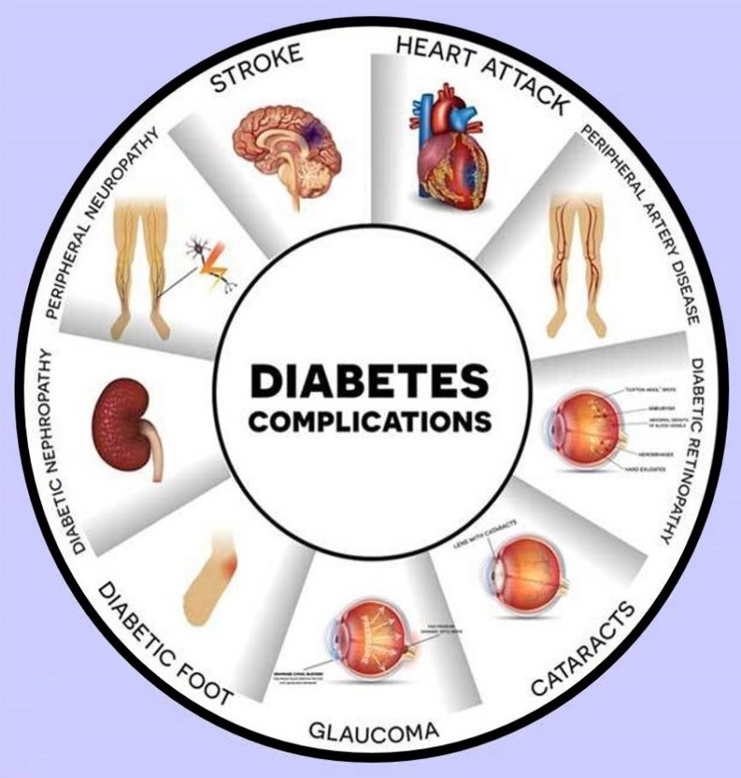

Observations made during the community survey: 14
- Diabetes mellitus cases have been on rise in this areas
- People in Nagarajupeta are aware about the complications of this disorder.
- Established lab facility is available in surrounding hospital of Nagarajupeta
After the survey, it has been concluded that there is a correlation between food habits and prevalence of diabetes
- It is less prevalent in people who are engaged in physical labour.
- Some physical labour may become diabetic at the later stages of their life normally.
- For many cases studied, diabetes occurrence has hereditary background.
- Old people suffer from diabetes more when compared to young people.

Precautions to be taken:
Once the person is found to be a potential diabetic, precautions should be taken.
- Reduce stressors
- Regular diet should be followed
- Less dependance on carbohydrate diet
- Regular check ups
- Glucose levels in the blood and urine levels are to be tested regularly.
- Increase Activity Level
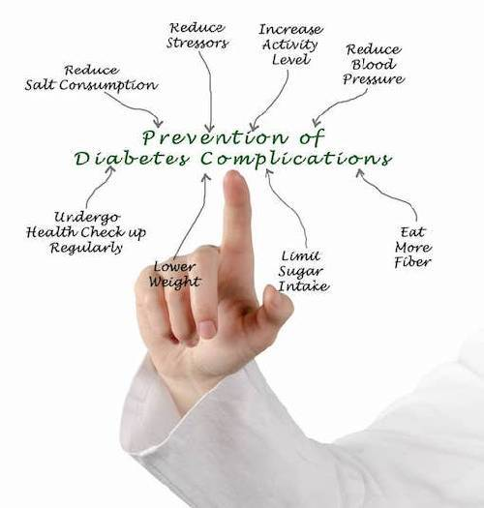

Prevalence of diabetes in diffirent age group based on questionnaire
15
S.No | Number of households interviewed | Number of diabetics found | Prevalence of diabetes in different age groups
S.No | Number of households interviewed | patients | Young | Adult | Old
1 | 120 | 21 | 2 | 6 | 13

prevalence

Age groups
Prevalence of diabetes in diffirent gender based on questionnaire

17
S.No | Number of households interviewed | Number of diabetics found | Prevalence of diabetes in different gender
S.No | Number of households interviewed | patients | female | male
1 | 120 | 21 | 5 | 16

prevalence

gender

Prevalence of diabetes based on economical status based on questionnaire
18

S.No | Number of households interviewed | Number of diabetics found | Prevalence of diabetes based on economical status
S.No | Number of households interviewed | patients | Poor | Middle | Rich
1 | 120 | 21 | 7 | 9 | 5

prevalence

Economical status

Discussion & Conclusions:

After this community survey the following conclusions are drawn.
- Prevalence of diabetes is more in old age people compared to young and adult.
- Prevalence of diabetes is more in male compared to female.
- Prevalence of diabetes is high in poor and middle class people than rich people.
- Diabetes mellitus, although a hormonal disorder, its predisposition is caused by several factors. Stress is the main culprit in creating diabetic conditions in a person. Hence ‘destressing’ oneself is the preventive measure.
- As the urban segments are taken for survey, it is observed that prevalence of diabetes is more now in urban segments because of the shift in lifestyle. Thus, diabetes mellitus may also be treated as lifestyle disorder. Healthy lifestyle can make us antidiabetic. Regular physical exercise is an antidote to diabetes. In agrarian families, incidence of diabetes is less as they involve themselves in physical labor.
- Possibility of becoming diabetic increases with the use of electronic gadgets like television. Hence, moderate body movements are recommended while watching television serials.
- Less carbohydrate diet is the best remedy to diabetes. Eating in instalments is a healthy habit. Eating between meals should also be avoided. Junk food should be discontinued. Vegan lifestyle may reduce the chances of becoming diabetic.
It is found out that, diabetes is a disease that can be managed efficiently without affecting the quality of life. It makes our life sweeter and also easier, if we have minimum awareness regarding this disorder.

Acknowledgements:
Smt,Dr.P.Subbalakshumma, Principal, SKR & SKR Govt.College for
Women(A),Kadapa
Dr.V.Ravisekhar, Faculty mentor, Govt.College for Women(A),Kadapa
Dr.P.Sachi Devi,Incharge,Dept of Zoology,Govt college for Women(A),kdp
All my Classmates

20
References

- Akari S, Mateti UV, Kunduru BR. Health-care cost of diabetes in South India: A cost of illness study. J Res Pharm Pract (2013) 2:114.
  - PubMed Abstract | Google Scholar
- Mather H, Verma N, Mehta S, Madhu S, Keen H. The prevalence of known diabetes in Indians in New Delhi and London. J Med Assoc Thailand Chotmaihet Thangphaet (1987) 70:54–8.
Google Scholar
- Guariguata L, Whiting DR, Hambleton I, Beagley J, Linnenkamp U, Shaw J, et al. Global estimates of diabetes prevalence for 2013 and projections for 2035. Diabetes Res Clin Pract (2014) 103:137–49.
PubMed Abstract | Google Scholar
- Dagenais GR, Gerstein HC, Zhang X, McQueen M, Lear S, Lopez-Jaramillo P, et al. Variations in diabetes prevalence in low-, middle-, and high-income countries: results from the prospective urban and rural epidemiological study. Diabetes Care (2016) 39:780–7.
PubMed Abstract | Google Scholar
- Nichols GA, Schroeder EB, Karter AJ, et al. Trends in diabetes incidence among 7 million insured adults, 2006-2011: the SUPREME-DM project. Am J Epidemiol. 2015 Jan 1;181(1):32–9. [PMC free article] [PubMed]
- Maruthur NM. The growing prevalence of type 2 diabetes: increased incidence or improved survival? Curr Diab Rep. 2013 Dec;13(6):786–
94. [PubMed]
- Misra A, Pandey R, Devi JR, Sharma R, Vikram N, Khanna N. High prevalence of diabetes, obesity and dyslipidaemia in urban slum population in northern India. Int J Obes (2001) 25:1722.
Google Scholar

